SPEECH & LANGUAGE ACTIVITIES
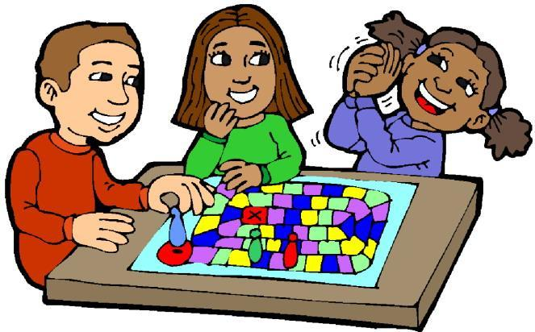

**Articulation cards can be made by cutting out pictures with your child's sound from books and magazines and gluing them to 3x5 index cards.

ARTICULATION ACTIVITIES
- HIDE AND SEEK - Parent hides articulation cards around one room of the house and as the child finds them, he/she names them using their best sound.
- MYSTERY PICK - Parent chooses a winning card, places the card back in the deck, shuffles and fans out the cards. Child takes turns selecting cards and saying the word on the card until they pick the "winner".
- BEAN BAG TOSS - Scatter the articulation cards on the floor. Select a winning card. Have the child stand a few feet away and try to toss a bean bag into a card. The child must say the word on the card that that bag lands on until they find the "winning" card.
- FISHING FOR WORDS OR NUMBERS - This can be done two ways. Either use a fishing pole (a dowel rod works great) with a magnet attached via string to pick the articulation cards with paper clips attached, or use the pole to pick up fish with numbers on them. The number indicates how many words they have to say.
- GUESS WHAT! - Cover an articulation card with a blank index card. Use the blank card to slowly unveil the picture on the articulation card. The child must guess (and correctly produce the word) before the picture is totally unveiled.
- PICK 2 - The child has to pick two cards from the deck at random and use both words in one sentence that makes sense and with correct articulation. Make this game more challenging by using three words.
- ARTICU-BOWL - Attach cards to bowling pins (empty soda bottles work great) and have the child bowl over the pins. As s/he picks up the pins, s/he must correctly say each word attached to the pins.
- MEMORY LINE-UP - Place 3, 4, or 5 cards in a row, have the child say the words, then close his/her eyes while you switch the order. S/he must put them back in order and say them again.
- WHAT'S MISSING? - Place 3-7 (depending on the level of difficulty) cards on a table. Give the child a minute or two to name all of the pictures and commit them to memory. Have the child close his/her eyes while you take one away. When the child opens their eyes, they have to guess which card is missing and name it using good articulation.
- TWISTER ARTIC - Toss several articulation cards into the air. Leave them where they land but be sure all cards are face up. Instruct the child to put as many body parts (elbows, hands, fingers, nose, etc.) on as many cards as s/he can. S/he must name each card that s/he touches.
- BALLOON BOUNCE - Bounce a balloon and try to keep it in the air. Each time the child hits the balloon, they must say a word with their sound correctly.
- BOARD GAMES - Any board game can be used. Have the child roll the die/dice. The number s/he rolls is both the number of spaces s/he moves and the number of words s/he has to say before moving.
- SOUND COLLAGE - Using magazines, have the child cut out several pictures that have his/her sound. If appropriate, talk about whether the sound is at the beginning, middle or end of the word. As the child says the word, s/he glues the picture to a large piece of construction paper to make a collage.
- TREASURE HUNT - Go on a treasure hunt around your house to look for things that have your child's target sound. Practice saying each word as you find things.
- CAR FUN - While in the car, look for things that have you child's target sound. Have a contest to see who can find the most. If you find something, have your child use the word in a sentence and vice versa.
- I SPY - One person chooses a visible object with the child's target sound (i.e. a "clock" if the target sound is /k/). That person gives the clue, "I spy with my little eye something that's ___" (gives a word to describe the clock). The other person asks questions to try and figure out what the object is.

LANGUAGE ACTIVITIES
GRADES K-2
- Choose books of interest to read to your child and for each page or paragraph (depending on the age of your child), ask comprehension questions, such as who, what, when, where, why and how. If they have difficulty with answering, assist them by modeling what a "where" answer sounds like; add information to your child's answers.
- Retell stories or books "in your own words," one-to-one or as a family. Model retelling, and then ask your child to do the same in a comfortable setting. If this is too much for your child, "chunk" the story or text and every so often have them tell a part or the story, or "what's happened so far."
- Read a variety of fiction and non-fiction books to your child. This will help in them in later grades when they read textbooks in science and social studies, when they read for factual information, and when they learn research methods.
- When reading together discuss new or complex word forms as you run across them. Children may benefit from highlighting or paraphrasing the following: words that are opposites (hot - cold), words that mean the same thing (big - large), and words that have more than one meaning (feet as a body part - feet as in measurement).
- Play categorization games with your child. For example, name as many animals, sports, colors, etc., as you can. Teach your child what to do and say if they don't know an answer. Start by asking them what they do know if they answer, "I don't know."
- Play same/different games with your child. State two items, for example. popsicle and ice cream cone; ask how the two items are the same and different.
- If your child uses incorrect grammar structures, "I gotted a A on my project," model the correct grammar by saying, "Oh, you got an A on your project."
- If your child is difficult to understand because she or he uses non-specific words during stories or explanations, (for example, "We went there and got the stuff for the thing,") you can label the non-specific words as "words that don't tell us much," or as "confusing words." Model for them how to be more specific. Example: "Your class went to the library to get books for the read-a-thon," now you tell me again.
- You can practice sequencing with your child by cutting out newspaper funnies, or cartoons. After you read them have your child put them in the correct order and tell the story. Encourage them to use terms such as, first, second, third, and then, next, last.
Practice sequencing with your child by using a real life situation such as, "tell me how to make a peanut butter and jelly sandwich.”

